**Altybayev Alikhan 23B151028**

To start with, this simple mobile app was inspired by equally lightweight application “I am rich”, personally, which was created to demonstrate, how wealthy people ready spend their money on every ‘luxury’ thing.

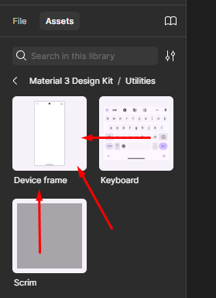 I’ve used the Figma platform since I have heard about it more frequently than other variants. First, I have registered my account, then I met the first problem – my screen was empty, and I’ve started searching for my screen. After 15 minutes it was found.

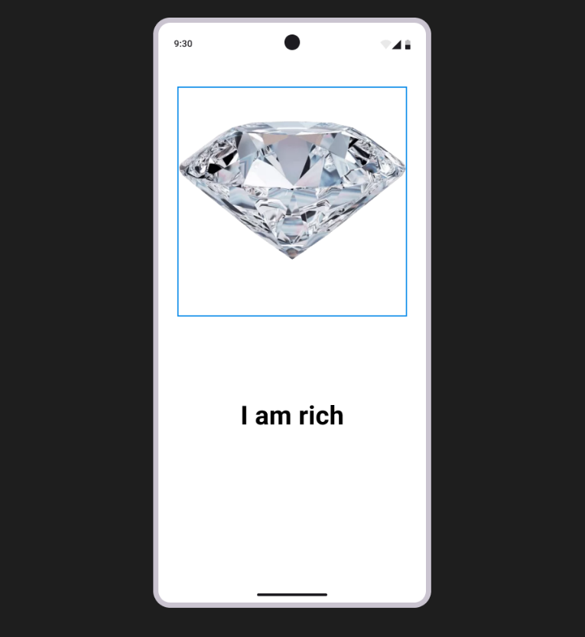 After these steps, it was easy to copy-paste the gem photo and put the text like “I am Rich”. In the end, I’ve finished and upload ed my project.